**Beneficiary Analysis**

**for**

**The Roman Catholic Episcopate of Iasi**

**Activity Profile:**Religion

**Address**: Bd. Ştefan cel Mare, nr. 26, 700064-Iaşi

**Phone**: 0232/212003

**Organisational structure and employees**:

**For The Roman-Catholic Parish The Dormition of the Virgin Mary:**

|  |  |  |  |  |
| --- | --- | --- | --- | --- |
| **Organism diecezan** | | **Functie** | | **Numar angajati** |
| Consiliu prezbiteral | | Preoti | | 31 |
| Episcopi | | 2 |
| Colegiul Consultantilor | | Preoti | | 10 |
| Consiliu Pastoral Diecezan | | Secretar | Preoti | 1 |
| Membri de drept | Preoti | 30 |
| Membri alesi din decanate | Preoti | 18 |
| Laici | 19 |
| Reprezentantii congregatiilor calugaresti | Preoti | 8 |
| Curia Diecezana |  | Moderatorul Curiei Diecezane | Preoti | 1 |
| Cancelar | Preoti | 1 |
| Vicecancelar | Preoti | 1 |
| Purtător de cuvânt | Preoti | 1 |
| Secţiunea Pastoraţie | Vicar episcopal | Preoti | 1 |
| Oficii | Preoti | 10 |
| Secţiunea Viaţa Consacrată şi Vocaţii | Vicar episcopal | Preoti | 1 |
| Oficii | Preoti | 5 |
| Secţiunea Cultură Creştină şi Dialog Ecumenic | Vicar episcopal | Preoti | 1 |
| Oficii | Preoti | 6 |
| Secţiunea Activităţi Socio-Caritative | Vicar episcopal | Preoti | 1 |
| Oficii | Preoti | 5 |
| Secţiunea Administraţie-Economie | Vicar episcopal | Preoti | 1 |
| Oficii | Preoti | 7 |
| Tribunalul Bisericesc | Vicar judecatoresc | Preoti | 1 |
| Judecator | Preoti | 5 |
| Apărătorul legământului | Preoti | 1 |
| Avocaţi | Preoti | 2 |
| Notar | Preoti | 1 |

**Employees of Romano-Catholic Teological Institute “Saint Joseph”:**

|  |  |
| --- | --- |
| **Functie** | **Numar angajati** |
| Moderator studii | 1 |
| Rector | 1 |
| Vicerector | 1 |
| Prefect de studii | 1 |
| Formatori | 4 |
| Secretar | 1 |
| Director economic | 1 |
| Directori spirituali | 2 |
| Asistent spiritual | 1 |
| Consiliul formatorilor | 10 |
| Profesori | 10 |
| Profesori invitati | 8 |
| Profesor pensionar | 1 |
| Studenti | 77 |
| Oameni de serviciu | 3 |
| Bucatari | 3 |

**Total number of employees(for the Roman-Catholic Iasi Episcopate):~1130**

**Total number of catholics:200,549**

**Building analysis:**

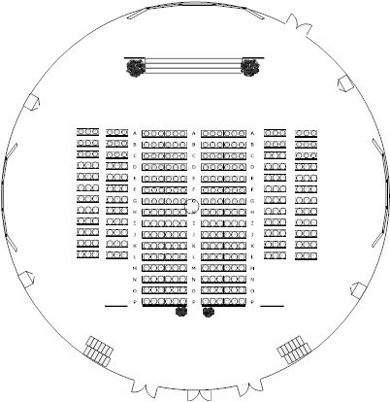

**1.**"Saint Virgin Mary, Queen" Cathedral

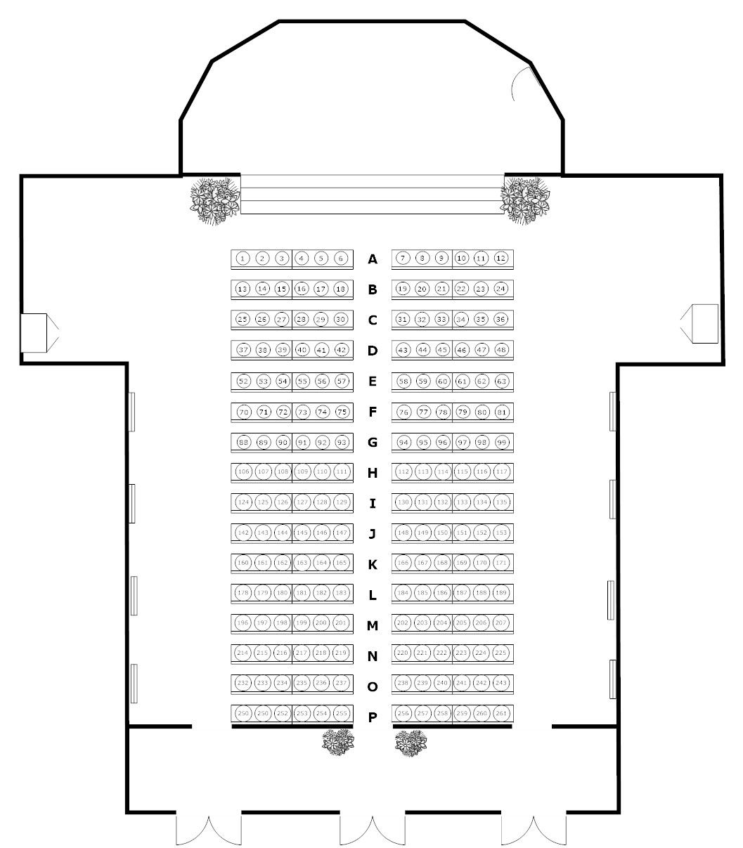

2.The Roman-Catholic Parish The Dormition of the Virgin Mary

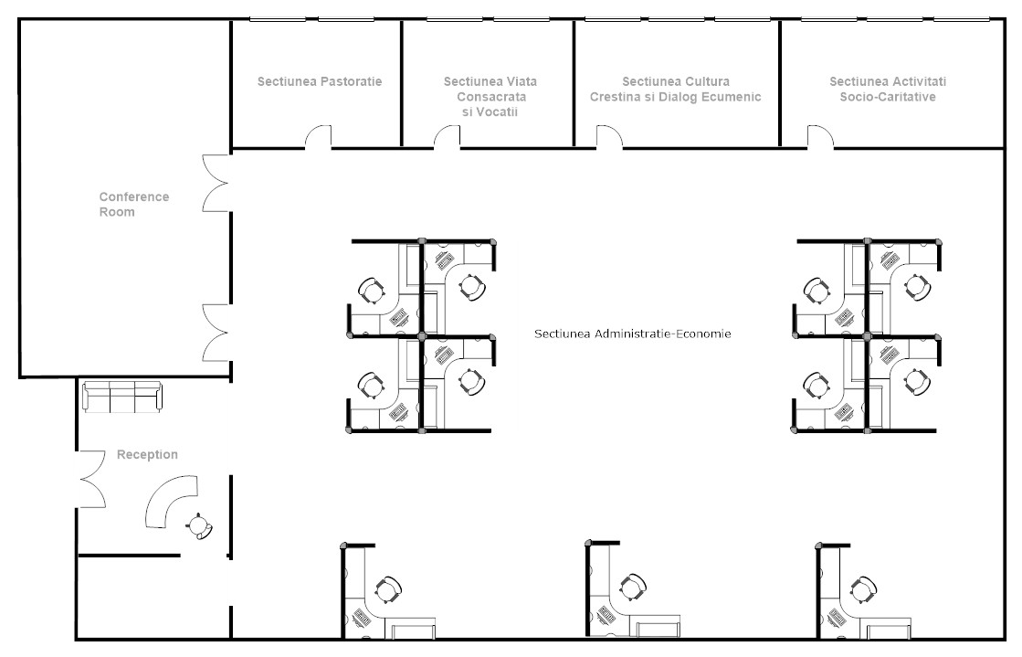

3.First floor of the Episcopate

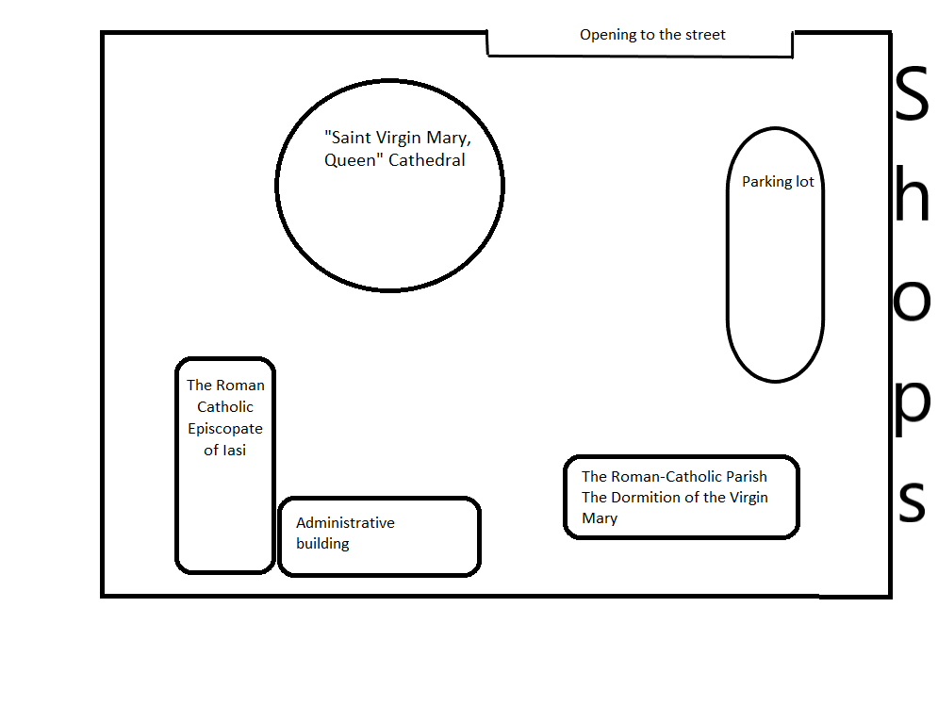

4.The outside space of the Church

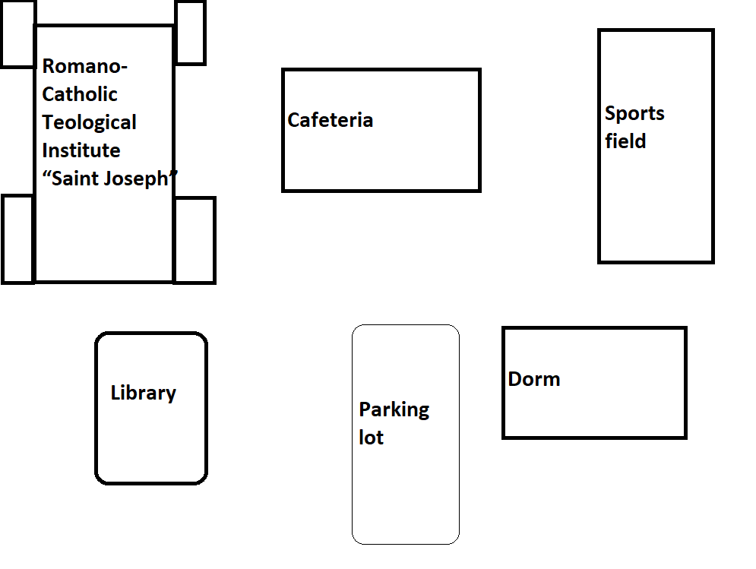

**The outside space of the church:**

* Administrative building:384 $m^{2}$
* The Roman Catholic Episcopate:192 $m^{2}$
* The Roman-Catholic Parish The Dormition of the Virgin Mary:671 $m^{2}$
* Green space outside:673 $m^{2}$
* Parking lot:1510 $m^{2}$ +310 $m^{2}$

**"Saint Virgin Mary, Queen" Cathedral:**

* 2 floors
* Each floor has many benches
* Round shape with the outer diameter - 38m
* On the outside, open space with many benches and statues
* Toilet outside

**Romano-Catholic Teological Institute “Saint Joseph”:**

* The surface is :3304 $m^{2}$
* Dorm:1227 $m^{2}$
* Parking lot:292 $m^{2}$
* Cafeteria:451 $m^{2}$
* Library:350 $m^{2}$

**The dorm:**

* 17 rooms
* 4 bathrooms
* 2 reading rooms

**The Roman Catholic Episcopate of Iasi:**

* Made of 2 buildings
* 2 bathrooms
* 9 offices
* 1 conference room
* 1 safe-deposit box
* 1 archive
* 1 reception

**Development plans:** none for the next 7 years.

**Special conditions:**

-providing internet access for the whole surface of the buildings and outside

-CCTV for every building

-inside and outside cameras for online transmission

-fast and secured connection